**Automation Setup**

Table of Contents

**Automation Setup 1**

**I.** **JDK Installation and Configuration 4**

**II.** **Eclipse Installation 10**

**III.** **Maven Set-up 13**

**IV.** **TestNG Set-up 20**

**V.** **Import Project & Run 21**

Revision History

|  |  |  |  |
| --- | --- | --- | --- |
| **Date** | **Description** | **Version** | **Author** |
| 6/18/2018 | Initial Draft | 1.0 | Camille Louie Olarte |
| 6/18/2018 | Updated the job aide and added screenshots | 1.1 | Camille Louie Olarte |
| 9/1/2021 | Added How to Run Script using TestNG | 1.2 | Camille Louie Olarte |
|  |  |  |  |

* **JDK Installation and Configuration**
* Download JDK from this link: <https://www.oracle.com/ph/java/technologies/java-archive-javase10-downloads.html>
* Click Accept License Agreement and download **jdk-10.0.2_windows-x64_bin.exe.**

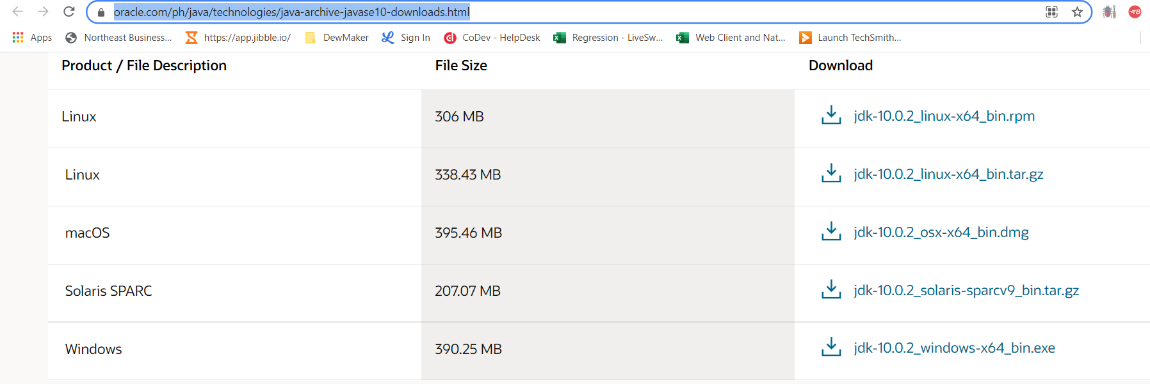

* Open the location folder for jdk. Double click or right click on the Java application installer *(Sample installation file name: jdk-10.0.2_windows-x64_bin (1).exe* then click Open. (Click Ok when prompted when installing the file.)



* 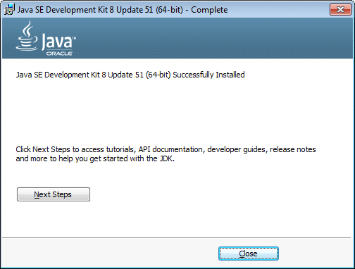Progress and wait until the application is successfully installed.
* Once copied successfully, navigate to Start > Enter ‘This PC’ > Right Click ‘This PC’ > Right Click ‘Properties’

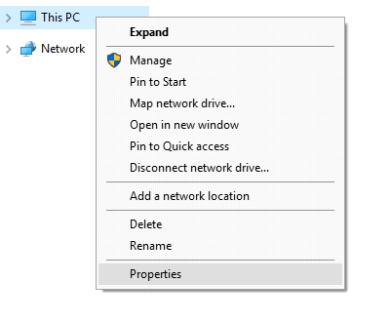

* Type ‘Advanced System Settings’ in the search bar and click the result*. (You can only access this if your current machine has the Administrator rights enabled for your User)*

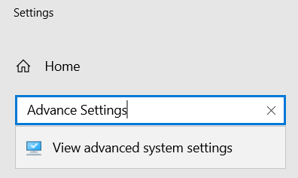

* Once the ‘System Properties’ dialog box appears, click ‘Environment Variables…’.

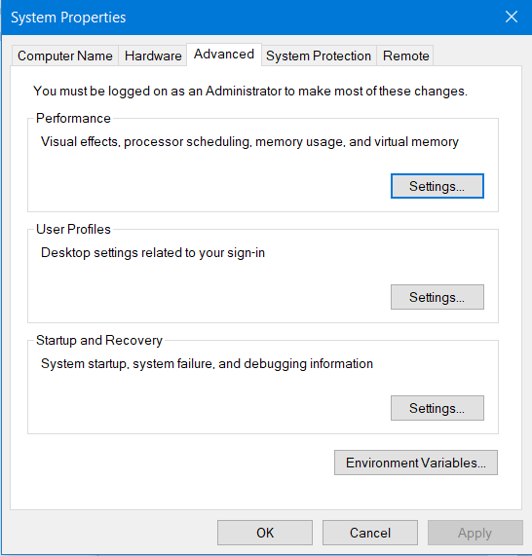

* Once the ‘Environment Variables’ dialog box appears, click the ‘New…’ button under the ‘System Variables’ section.

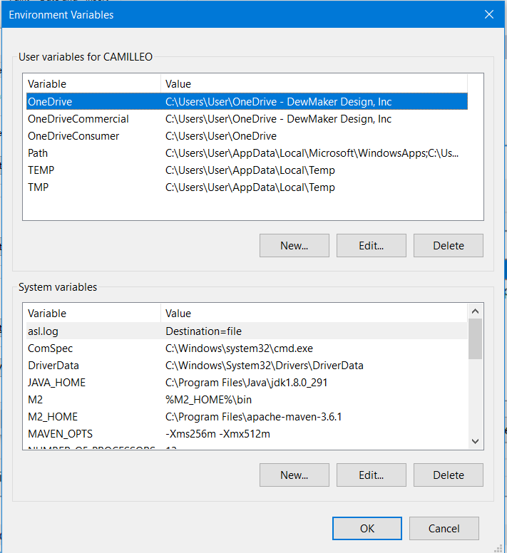

* Once the ‘New System Variable’ dialog box appears, enter the value **“JAVA_HOME”** as the **Variable Name** and the **file path** (e.g. “C:\Program Files\Java\jdk.1.8.0_162”) where the JDK was installed on the **Variable Value**. Then, click OK button.

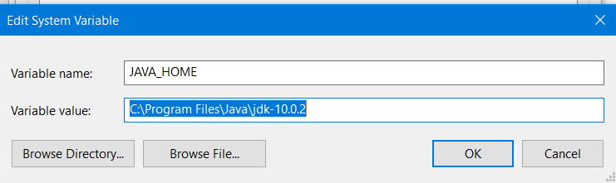

* Look for the variable name **“Path”** under the **system variables section** then click the Edit button.

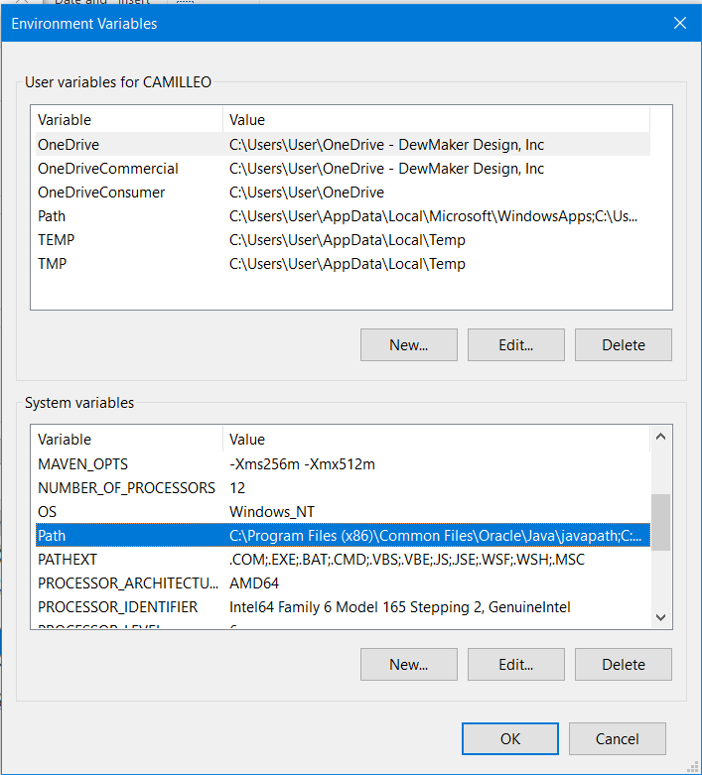

* Once the “Edit System Variable” dialog box appears, add the **“;%JAVA_HOME%”** in the end of the Variable Value field. Then, click OK button.

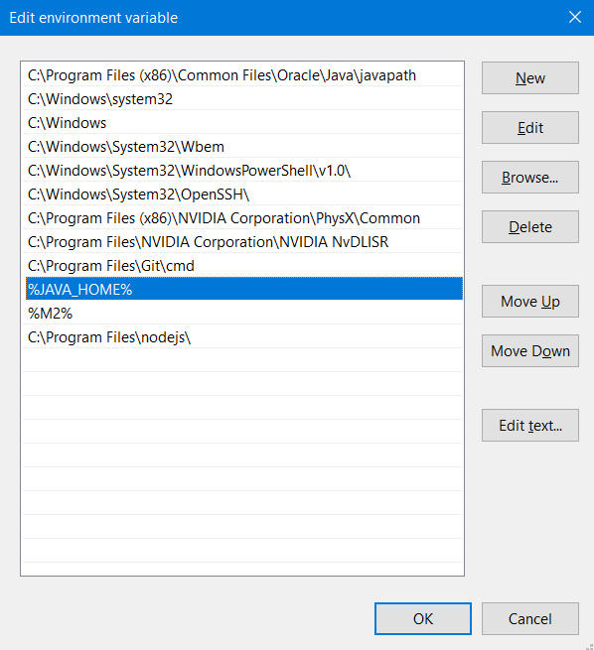

* Once done, navigate to Start Menu and type “CMD” (or Command Prompt) in the Start Menu search bar. This will open the command prompt.
* Enter **“java -version”** and validate if you get the same results as indicated on the screenshot below. Once you’ve get the same results (***output includes the java version***), this means that the JDK is successfully configured for our set-up of Selenium Webdriver.

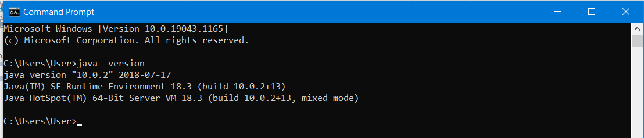

* Close the CMD/Command Prompt.
* **Eclipse Installation**
* Download Eclipse App in link <https://www.eclipse.org/downloads/download.php?file=/technology/epp/downloads/release/2021-03/R/eclipse-jee-2021-03-R-win32-x86_64.zip>
* Download Windows x86_64
* Click Download

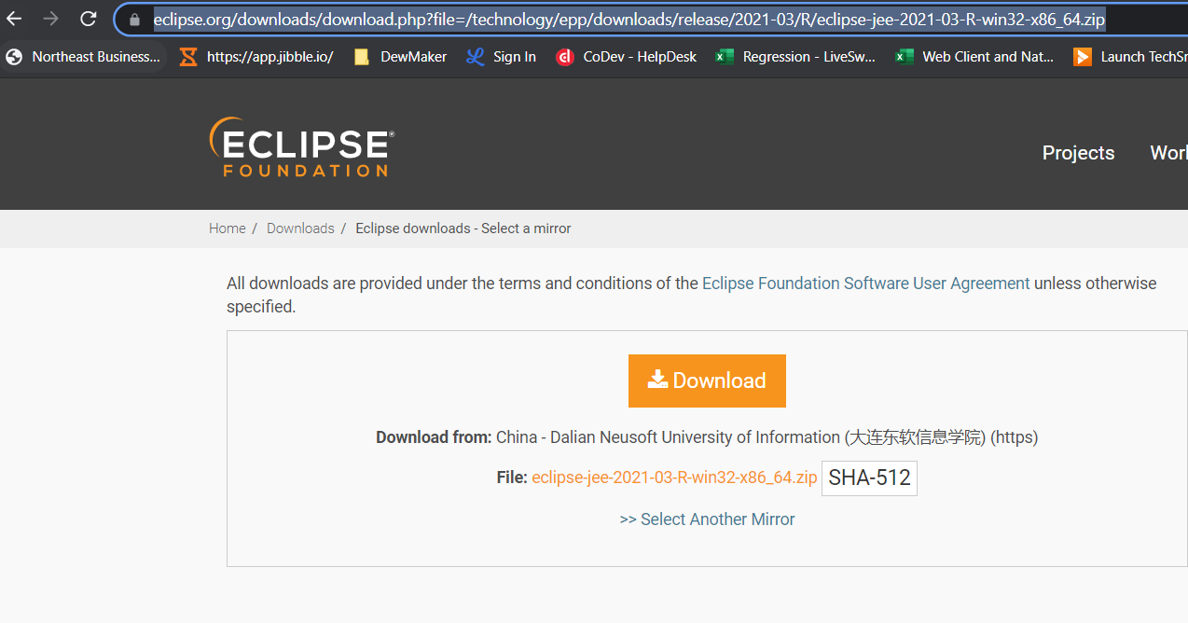

* Extract downloaded Zip file and look for Eclipse.exe, and Run as administrator

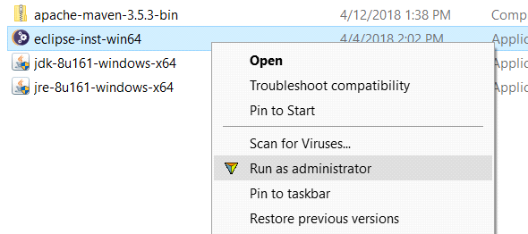

* Select Eclipse IDE for Java Developers

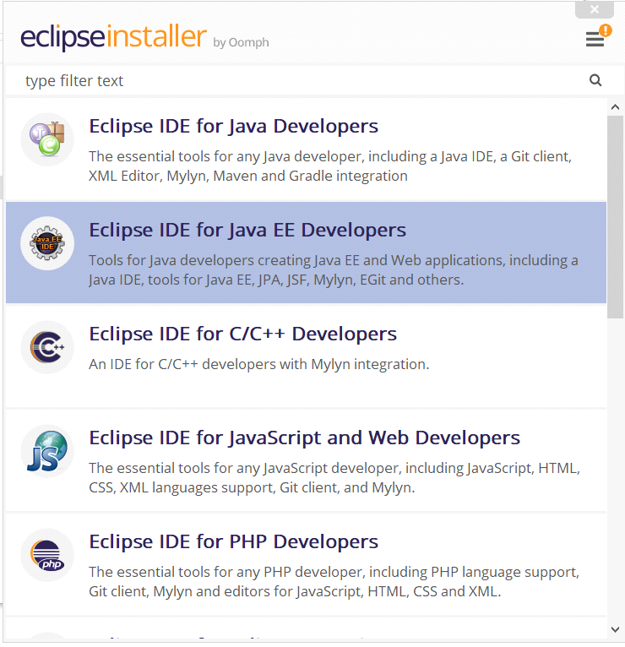

* Click install

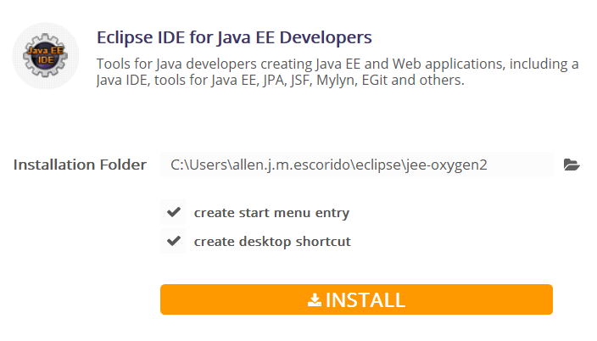

* Click accept

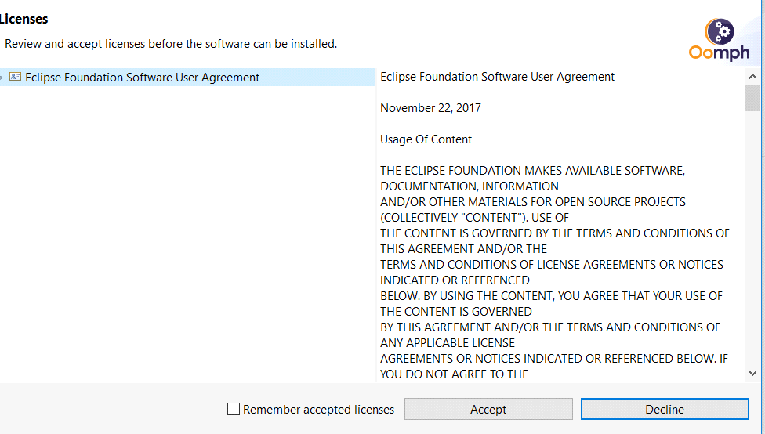

* **Maven Set-up**

**INSTALLATION:**

* **Maven Configuration**
* Download the Apache Maven in the link below and extract it afterwards.

<https://dewmaker-my.sharepoint.com/:u:/g/personal/louie_olarte_dewmaker_online/ERvh5TigxDRFmh2R6_EPGDsBnqo6tWzG0ILwcxurlIxzqQ?e=B9vWg7>

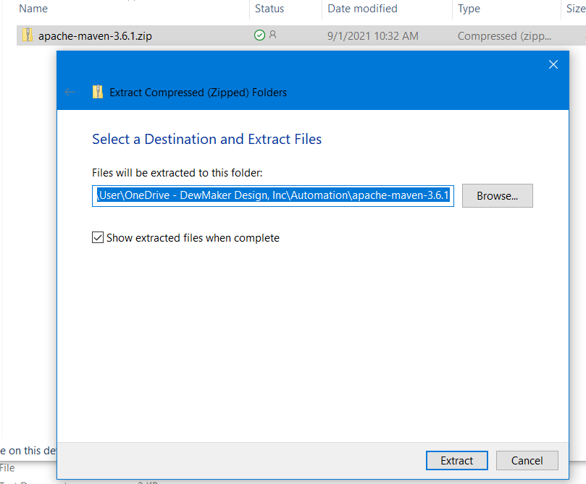

* Copy Maven file in Drive C > Program Files

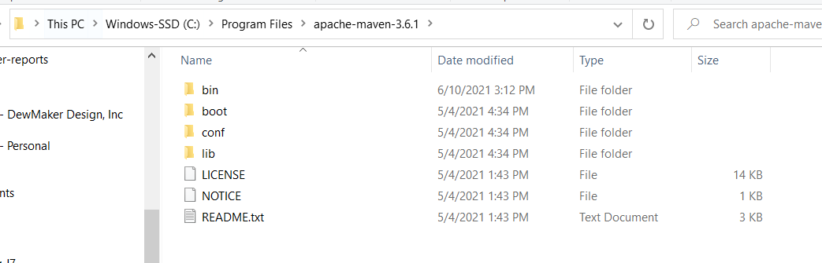

* Once copied successfully, navigate to Start > Enter ‘This PC’ > Right Click ‘This PC’ > Right Click ‘Properties’



* Type ‘Advanced System Settings’ in the search bar and click the result*. (You can only access this if your current machine has the Administrator rights enabled for your User)*



* Once the ‘System Properties’ dialog box appears, click ‘Environment Variables…’.



* Once the ‘Environment Variables’ dialog box appears, click the ‘New…’ button under the ‘System Variables’ section.

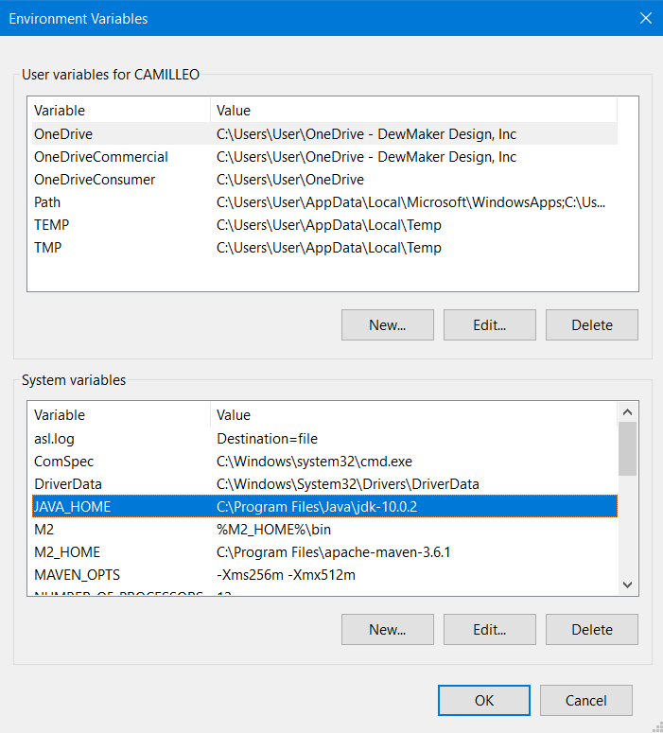

* Once the ‘New System Variable’ dialog box appears, enter the value **“M2”** as the **Variable Name** and the “**%M2_HOME%\bin**” as the **Variable Value**. Then, click OK button.

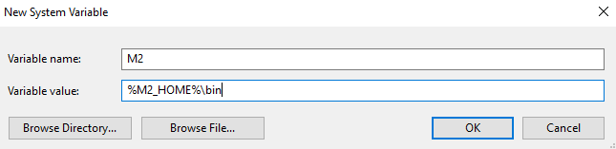

* Click the ‘New…’ button again under the **System Variables section.**
* Once the ‘New System Variable’ dialog box appears, enter the value **“M2_HOME”** as the **Variable Name** and the **file path** (e.g. “C:\Program Files\apache-maven-3.5.3) where the maven was stored on the **Variable Value**. Then, click OK button.

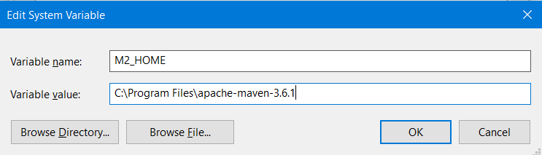

* Click the ‘New…’ button again under the **System Variables section.**
* Once the ‘New System Variable’ dialog box appears, enter the value **“MAVEN_OPTS”** as the **Variable Name** and the “**-Xms256m -Xmx512m**” as the **Variable Value**. Then, click OK button.

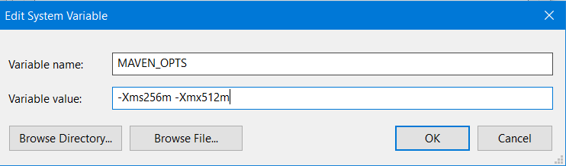

* Look for the variable name **“Path”** under the **system variables section** then click the Edit button.

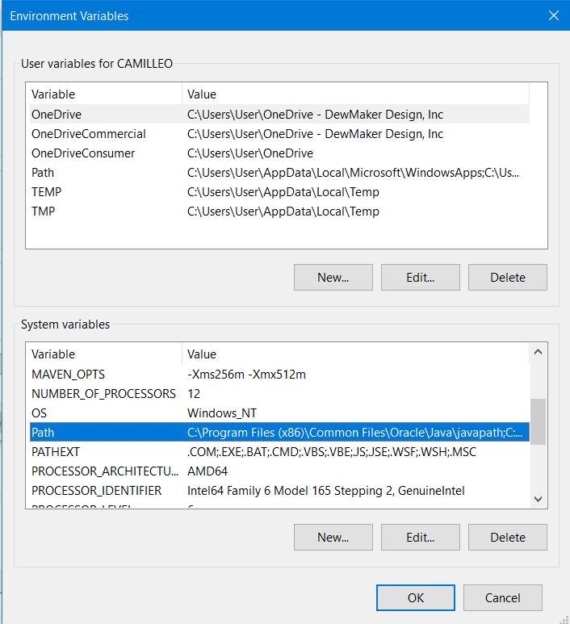

* Once the “Edit System Variable” dialog box appears, click “New” and add **“%M2%”.** Then, click OK button.

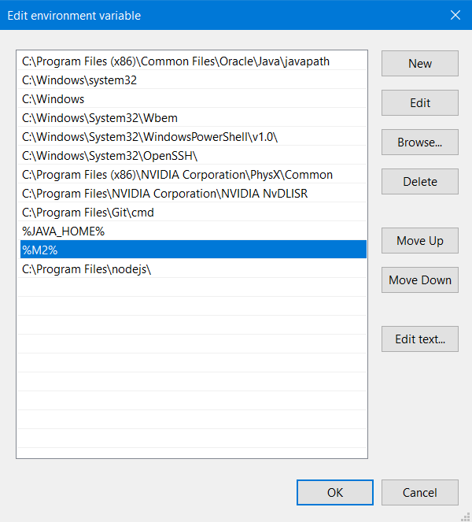

* Once done, navigate to Start Menu and type “CMD” (or Command Prompt) in the Start Menu search bar. This will open the command prompt.
* Enter **“mvn --version”** and validate if you get the same results as indicated on the screenshot below. Once you’ve get the same results (***output includes the maven version and file path and java version***), this means that the maven is successfully configured for our set-up of Selenium Webdriver (together with JDK setup).

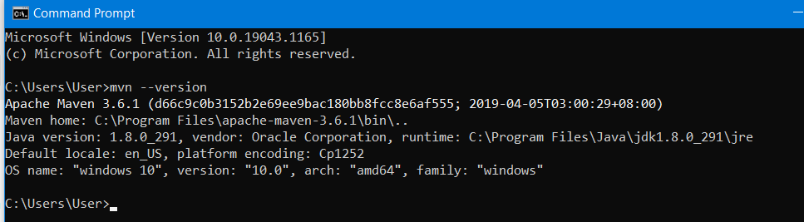

* **TestNG Set-up**

1. On the menu bar of Eclipse, click “Help”.

2. Select the “Eclipse Marketplace…” option.

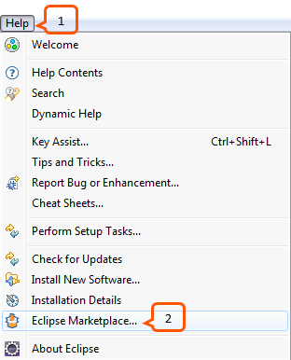

3. From the Search Tab type “TestNG” on the search box and press enter.

4. Click Install button.

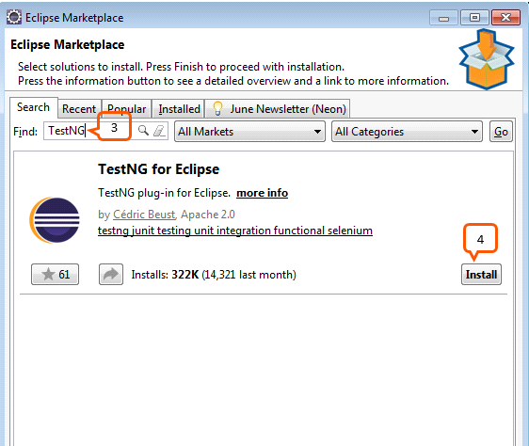

5. Click Confirm button on the next window.

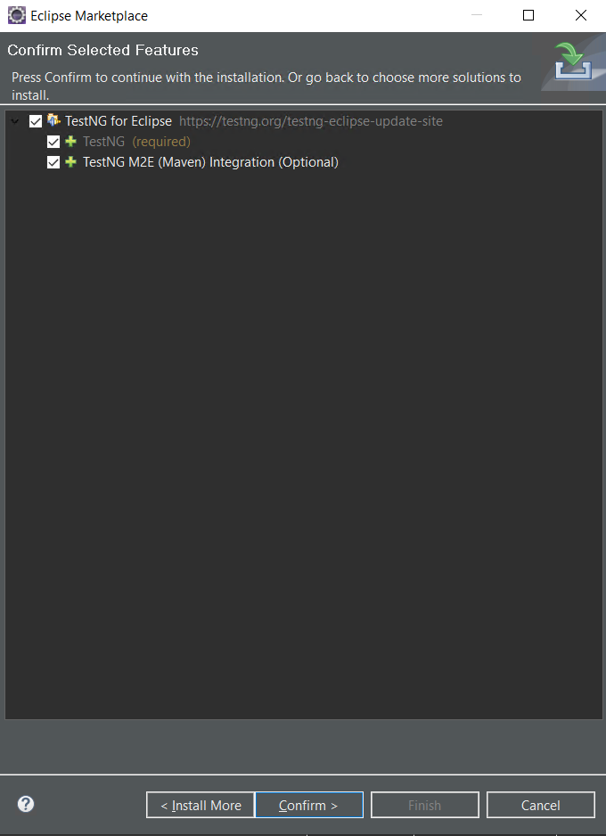

* Select option: “I accept the terms of the license agreement” then click Finish button.

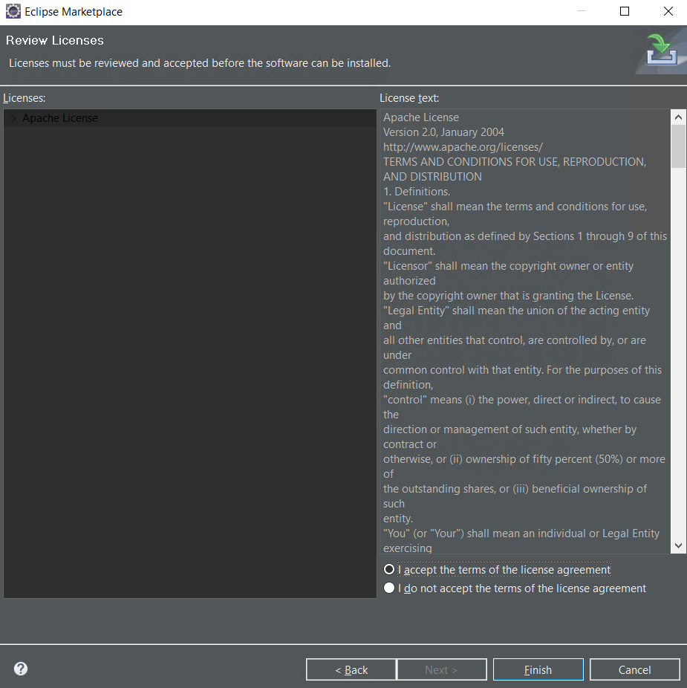

* Wait for the software to install.

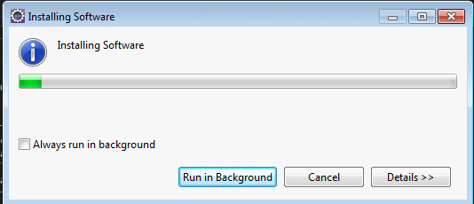

* Click Yes button to restart Eclipse.

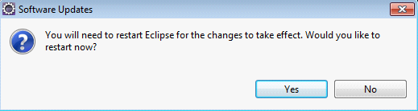

**Install Nature and Cucumber**

* Search for Cucumber and install both Cucumber and Natural

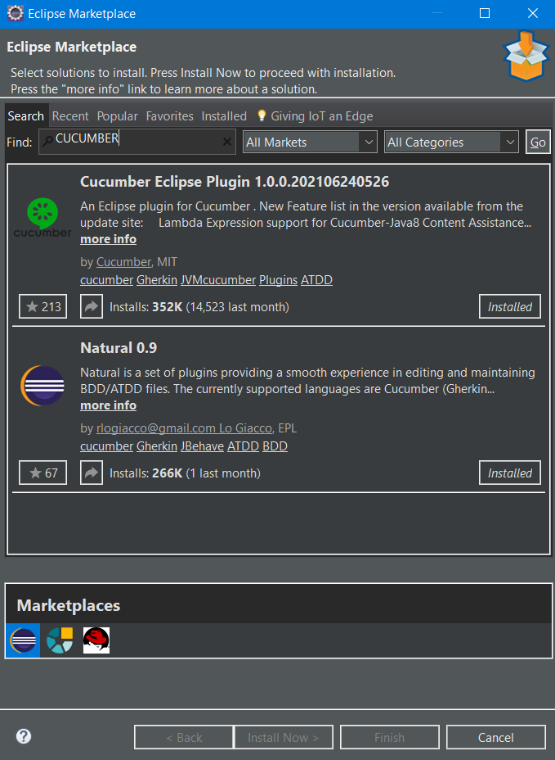

* Incase an error occurred for Natural 0.9, follow the steps below:

1. Click Help Menu and Click Install New Software

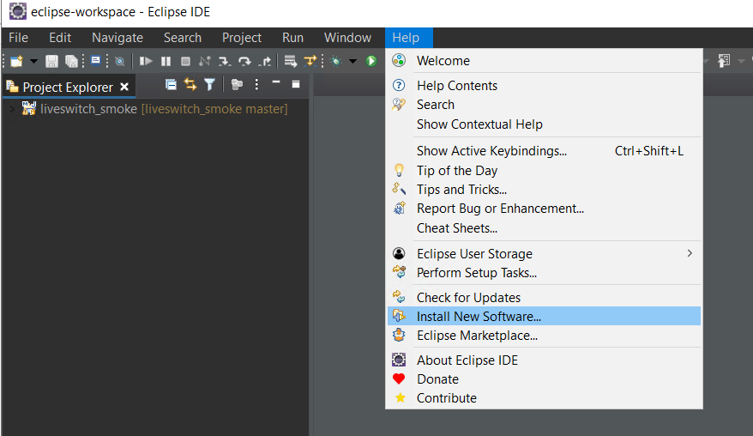

2. Enter "<http://rlogiacco.github.io/Natural>" in the Work with: and click Add button

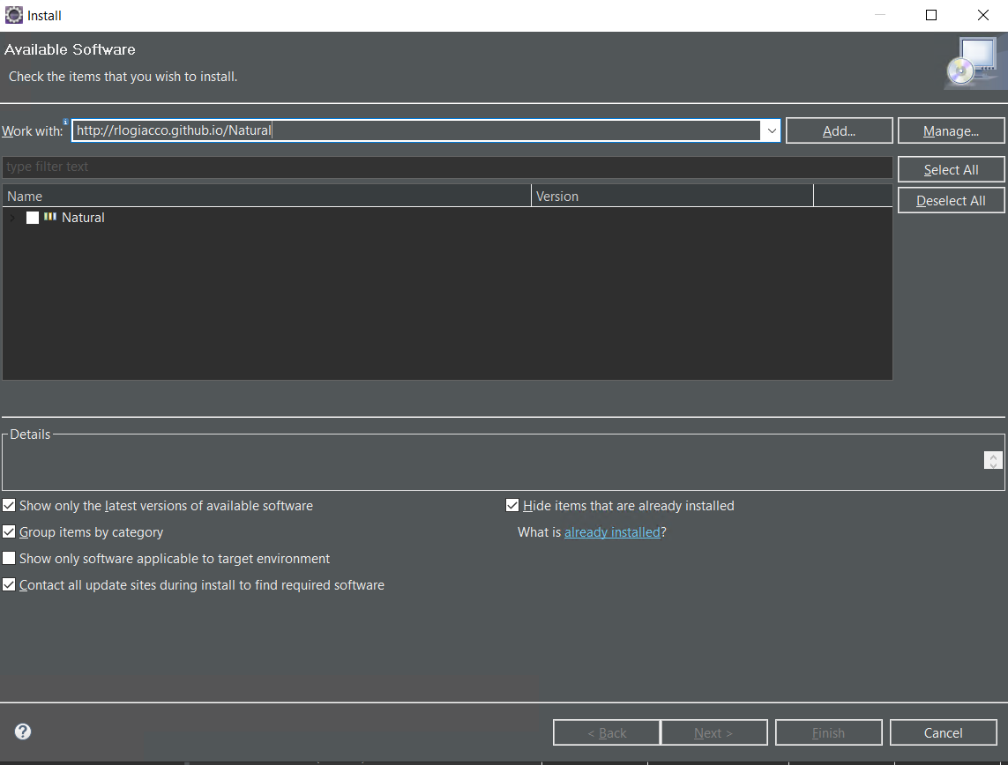

3. Tick the box Natural and Install or Continue. Wait for the installation to be completed.

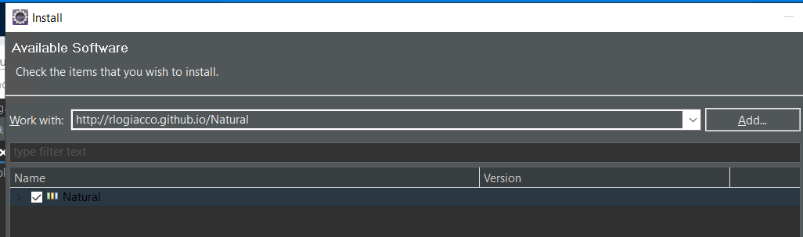

**V. Import Project & Run**

* Copy "liveswitch_smoke" in the your eclipse workspace.

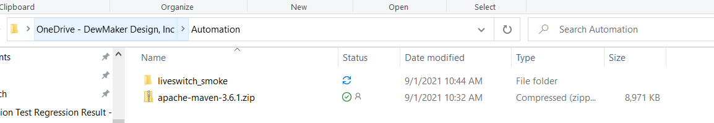

Copy to local Eclipse workspace

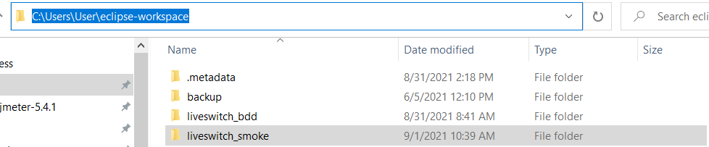

* Open Eclipse and Import liveswitch_smoke as project.

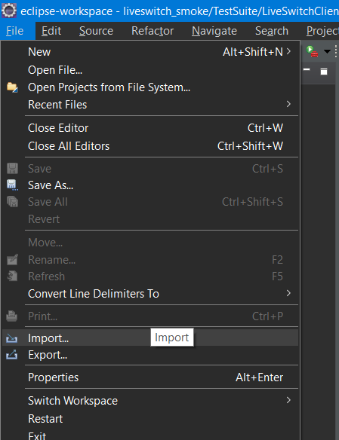

* Look for **Maven** folder and select **Existing Maven Projects,** click Next.

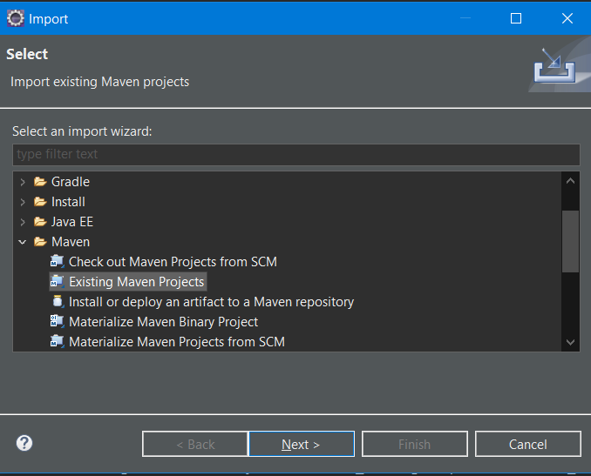

* Click Browse and look for liveswitch_smoke folder we copied.

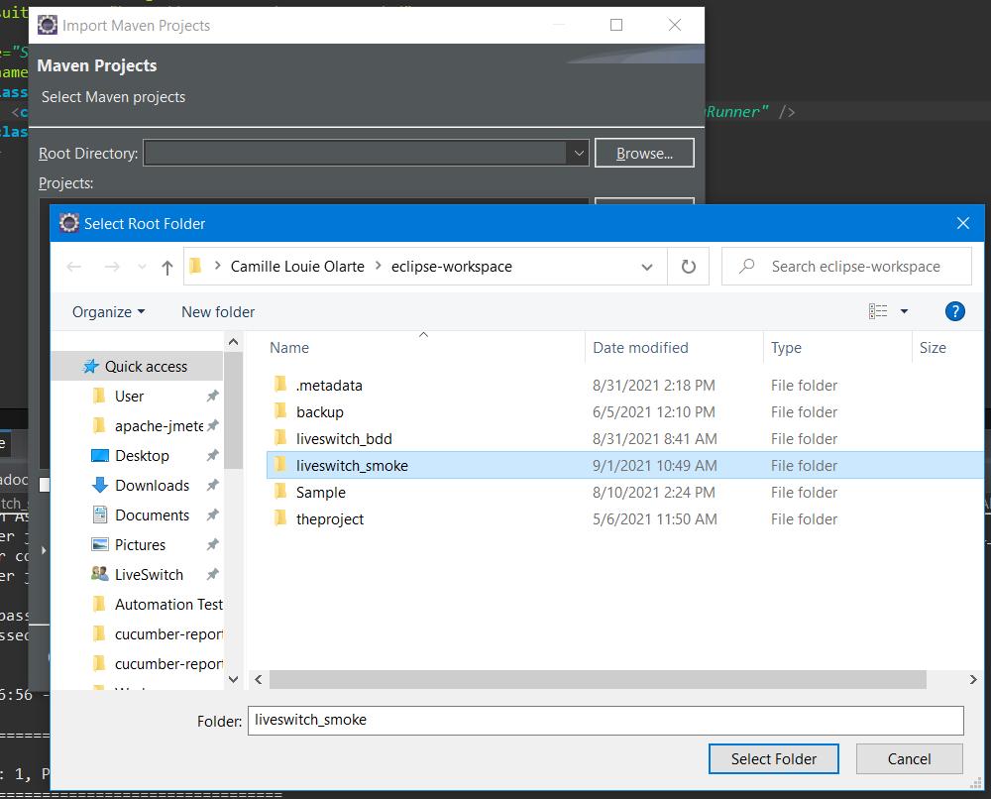

* Click Select Folder and Finish.
* Navigate to Smoke Test.xml under TestSuite > LiveSwitchClient folders in the project.
* Right click Smoke Test.xml and Run As TestNG Suite

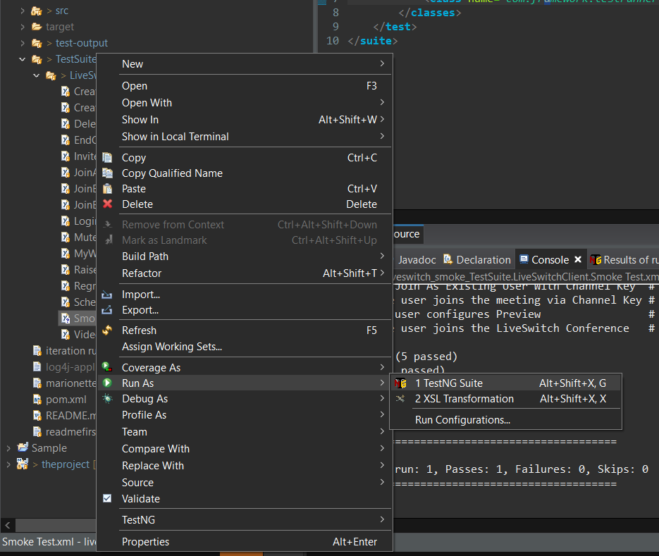

* Console should display like this

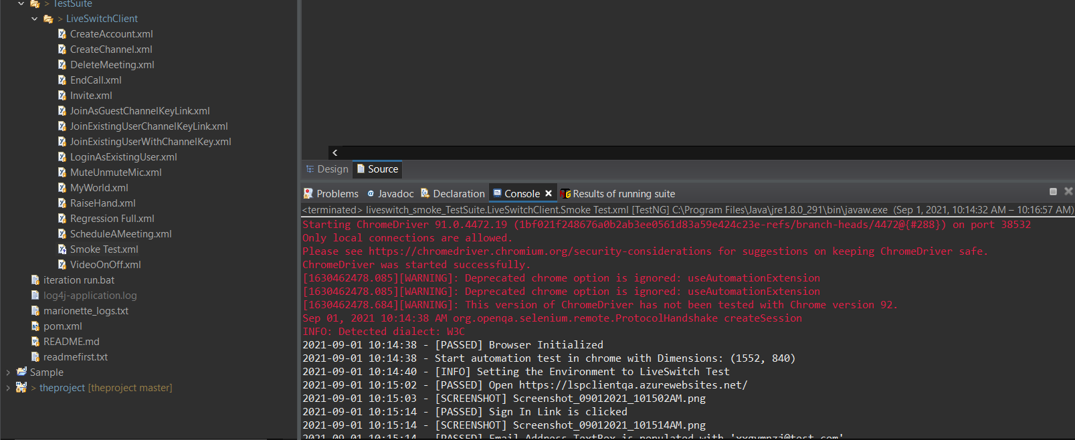

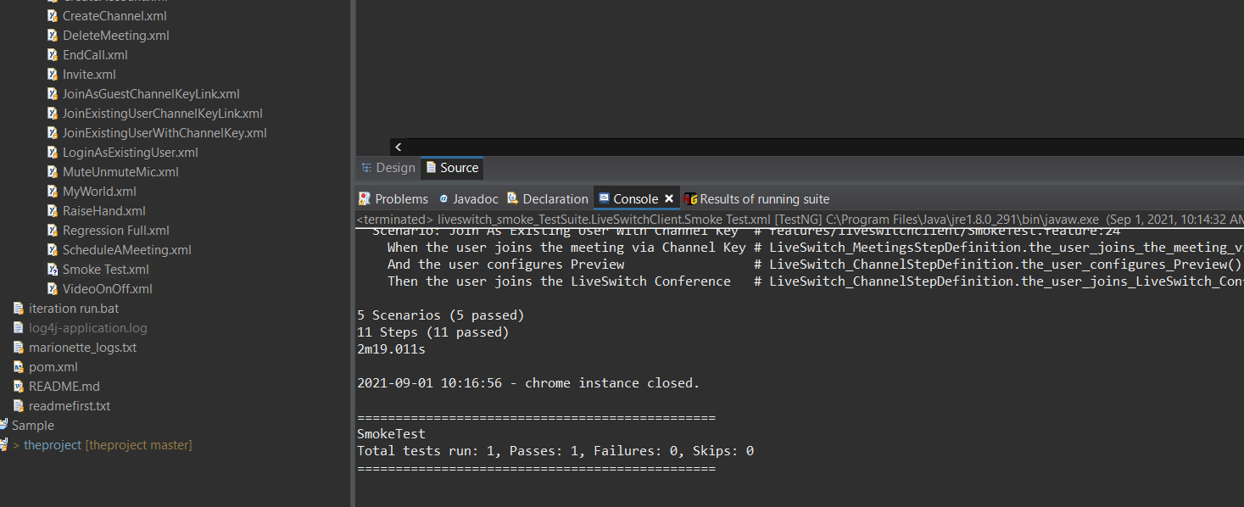

* After the run, Navigate to "eclipse-workspace\liveswitch_smoke\target\cucumber-reports" folder.

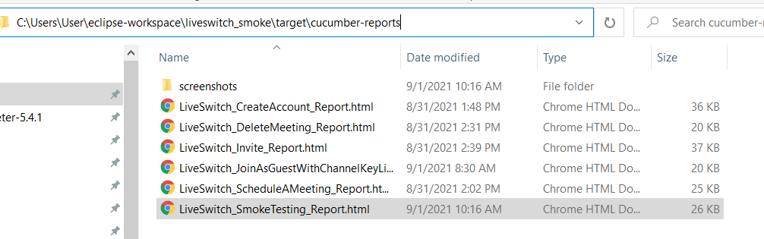

* Open html report file "LiveSwitch_SmokeTesting_Report.html"

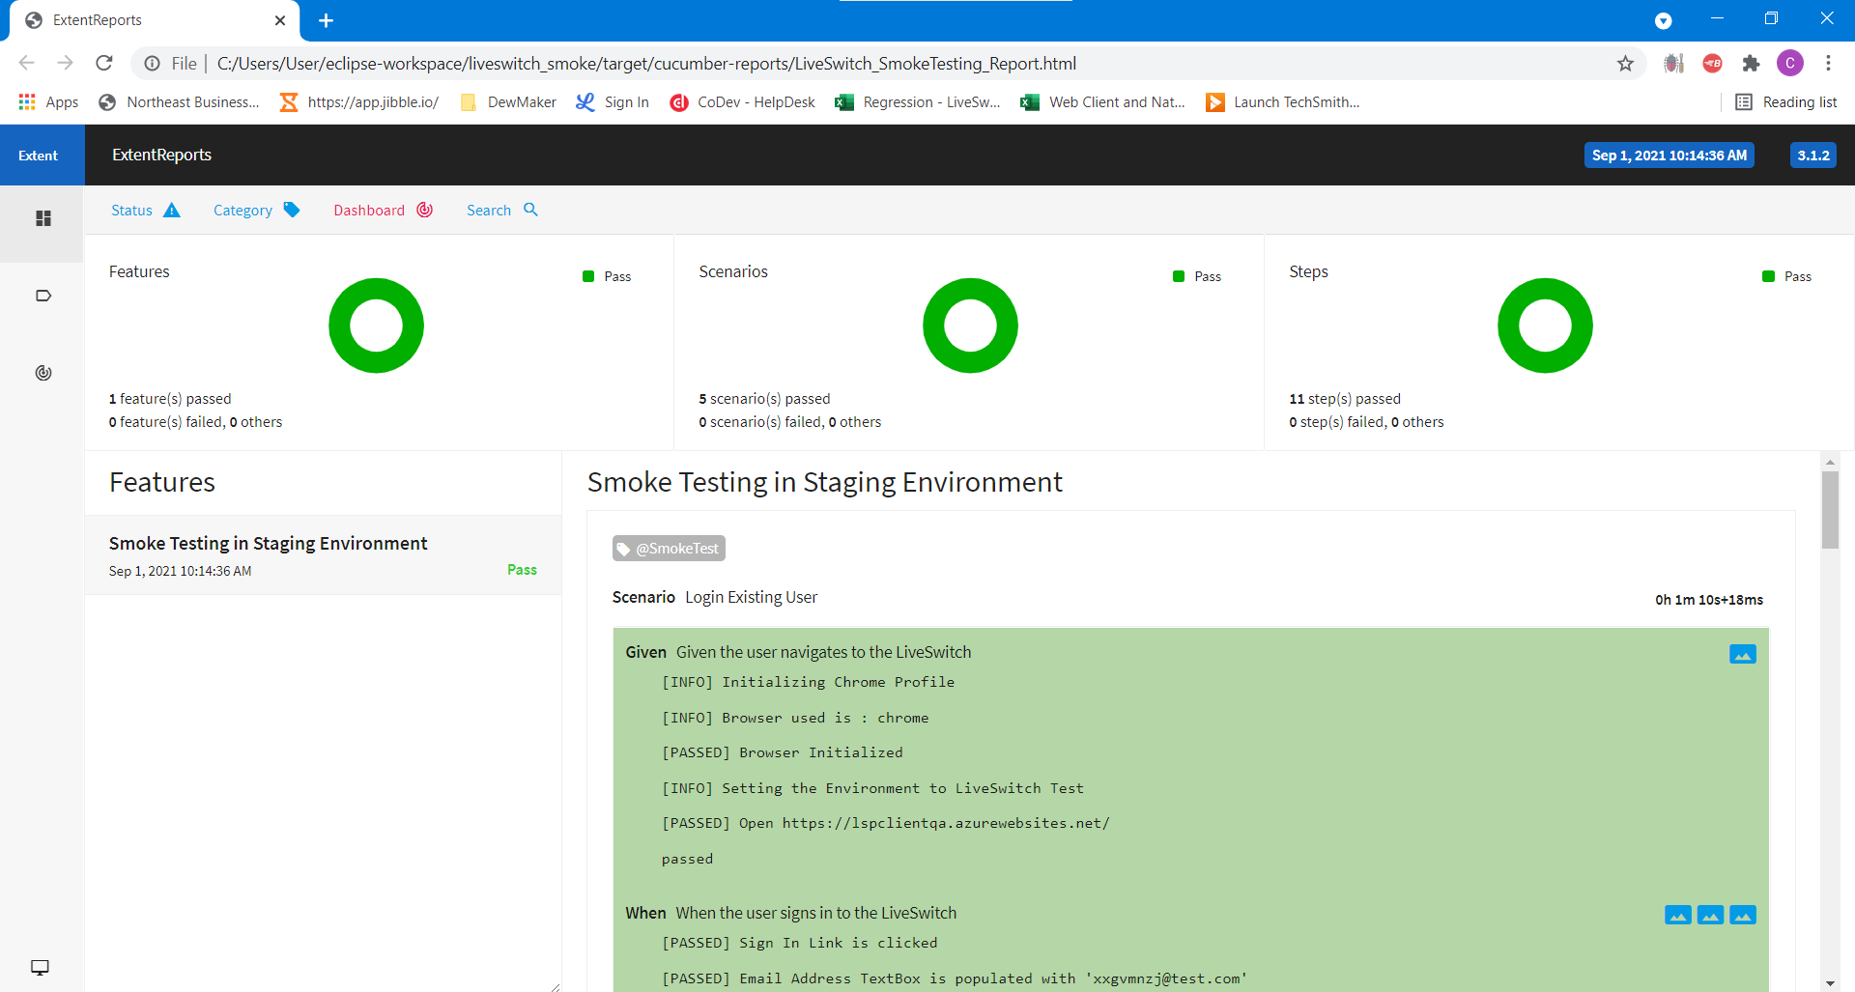

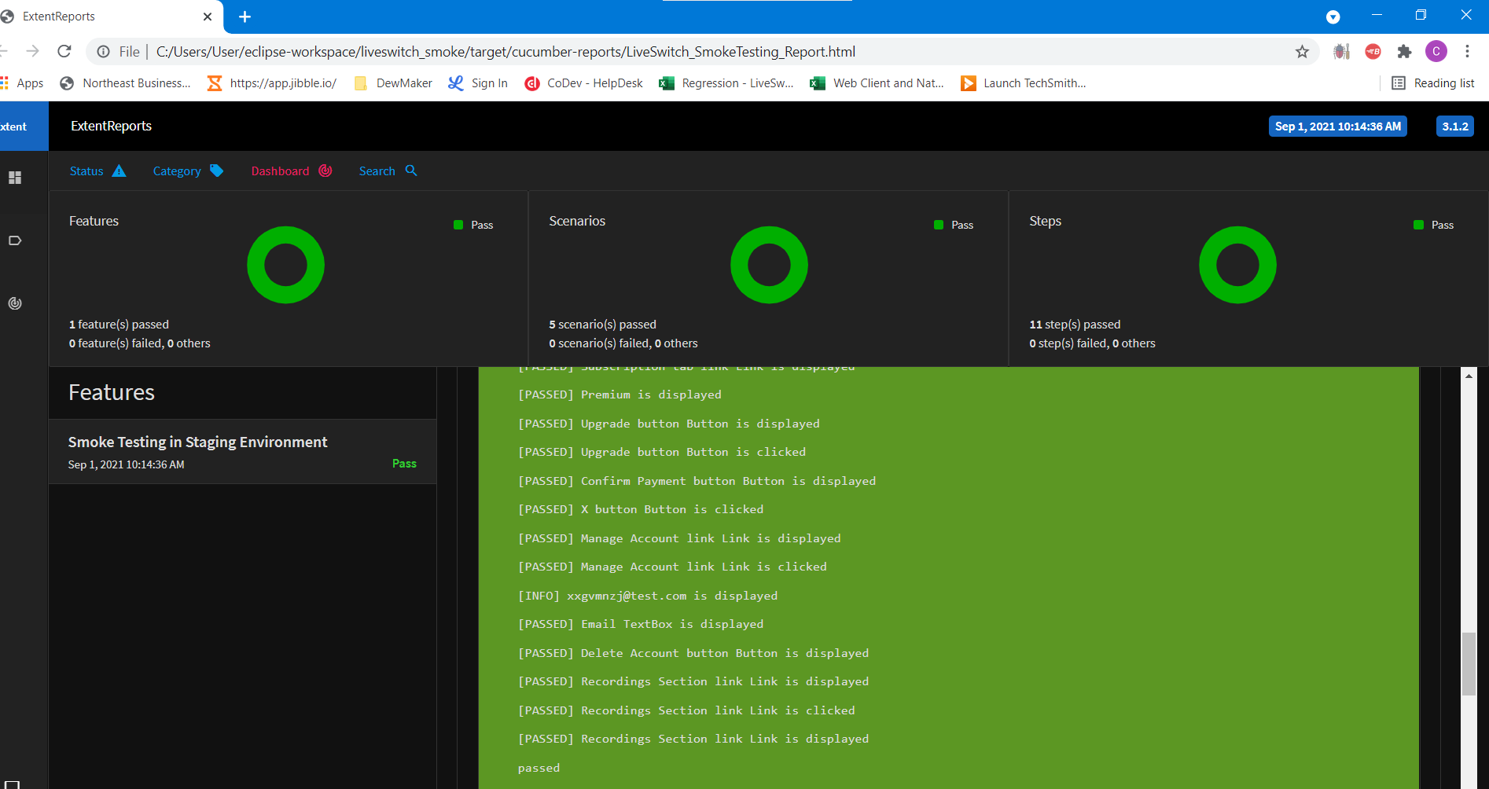

* **Run Batch file**

1. Navigate to "**eclipse-workspace\liveswitch_smoke**" folder. Locate for **"Smoke_Test_Run.bat**" and double click.

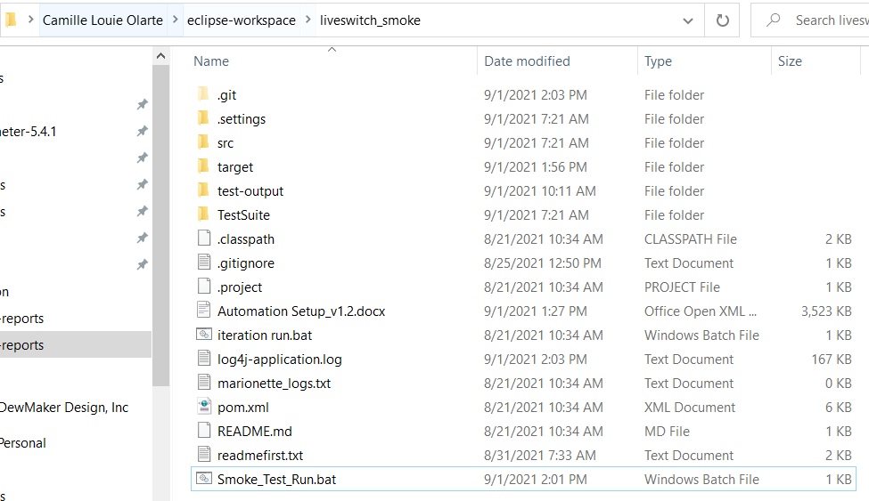

2. Wait until Build/Run is successful and no Failures.

